HOLLY PARK PRIMARY SCHOOL

NURSERY APPLICATION FORM

Surname: |  | Other names:
Date of birth: |  | Known as:
Place of birth: |  | Male Female
Length of time in U.K: |  | Nationality as recorded on passport:
Address:

Home phone number:

To which local authority do you pay your council tax?

Position in family? (e.g eldest of 2, only child etc) |  | Siblings in school? (Name and class)
PARENT/ GUARDIAN 1  Miss / Mrs / Ms/ Mr: | (surname) | PARENT/ GUARDIAN 2 Miss / Mrs / Ms/ Mr: | (surname)
Occupation: |  | Occupation:
Parent 1 mobile number: |  | Parent 2 mobile number:
Parent 1 home number: |  | Parent 2 home number:
Parent 1 work number: |  | Parent 2 work number:
Parent 1 email address: |  | Parent 2 email address:

Other Details
Does your child have any identified medical conditions or needs? If so, please give details

Does your child have any allergies? If so, please give details.

Has your child worked with any other professionals or benefited from other services? (e.g social worker, speech and language therapy, etc). If so, please give details.

Does your child have any learning or developmental needs?

Is your child entitled to Free School Meals?  YES / NO | Special dietary information:
Is there any other significant information about your child that we should know about? (adoption etc)

PLEASE NOTE THAT THIS APPLICATION DOES NOT GUARANTEE YOU A PLACE AT THE SCHOOL

FOR SCHOOL OFFICE USE
Date application received: | Birth certificate seen? | Y / N
Seen by: | 2 x proof of address seen? | Y / N
Potential start date: | JANUARY / SEPTEMBER | 20__

________________________________________________________________________

From the Head Teacher of Holly Park Primary School

To the parent[s] / guardian[s] of ________________________________________________________

We have received your application for your child to attend this school. The fact that a child’s name has been taken does not mean that a place will necessarily be available. This will depend on the number of applications, and if the school is oversubscribed account will be taken of brothers and sisters who are at the school and where the children live. Please keep this slip as a record of your application.

We will apply our admissions criteria at the beginning of February in the year before admission

Offer letters will go out to parents at the end of February in the year before admission

Parents will need to accept or decline any offer made by the date given on the offer letter

Late applications will be considered

Once offered a place, parents will be asked to fill in and return a form requesting:
- The sessions required
- Any extended hours

Once offered a place, parents will be given the dates for:
- An evening parent meeting
- Drop in sessions to visit the nursery with the child
- A home visit date
- A start date

Signed 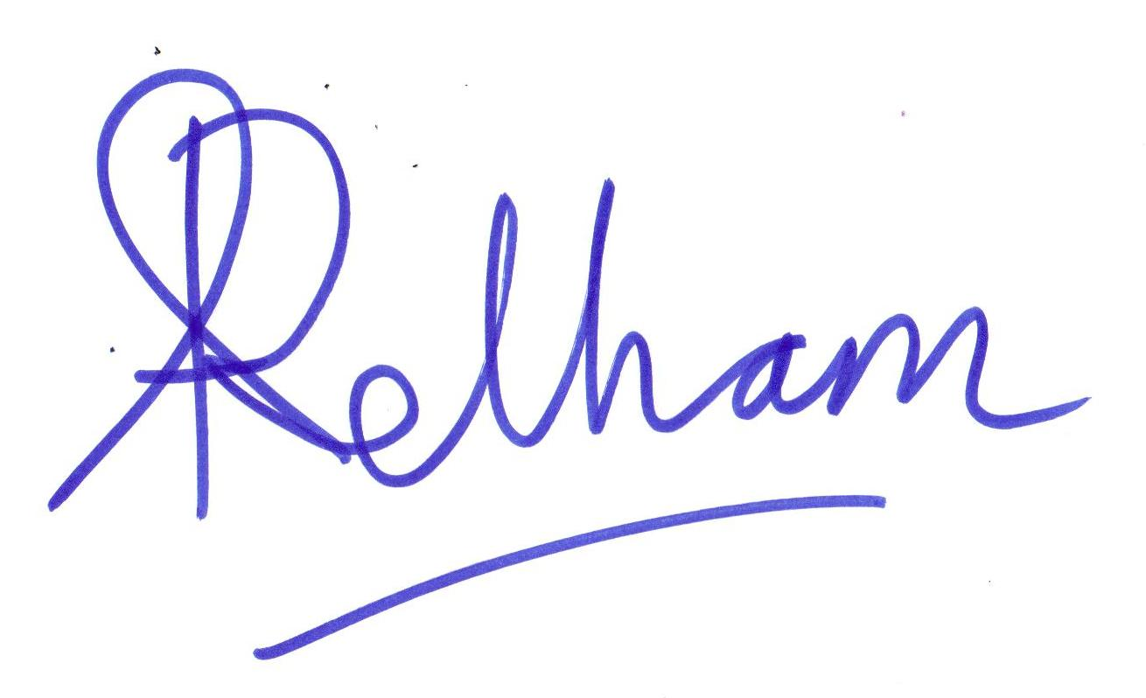

H O L L Y P A R K P R I M A R Y S C H O O L

Nursery Admissions Criteria in order of Priority

1 Children applying who are in the care of a local authority

2 Other children whom the Director of Children’s Service accepts have an exceptional medical, social or other need that the school is particularly able to meet. Applications in this category will be considered only if they are supported by an attached written statement from a doctor, social worker or other appropriate professional. Parents must demonstrate that there is a very specific connection between the child’s need and the school. Difficulties with child care arrangements because of work or other commitments would not be grounds for priority under this category. Information not provided at the time the application is submitted may not be considered at a later date

3 Children of staff who are currently employed by the school and are working at the school.

4 Children who, at the time of admission, have a sibling living at the same address who already attends the school. Siblings would include half, step, adoptive and foster siblings provided they also live at the same address as the applicant

5 Children living within the school’s defined area, with priority given to those who live closest to the school when measuring distance in a straight line between the front door of the child’s home and the main school gate

6 Children living outside the school’s defined area, with priority given to those who live closest to the school when measuring distance in a straight line between the front door of the child’s home and the main school gate

7 Applications made on behalf of twins or triplets – when the over-subscription criteria are applied to applications made on behalf of twins or triplets, they will be selected in random order and places will be offered accordingly. This could result in one (or two) children in a family being offered a place but not the other(s). Where relevant, the remaining child(ren) would be retained automatically on the school’s waiting list and would have priority should any vacancies arise at the school.

8 Tie Breaker situations:

    - Tie Breaker – distance will be used as a tie-breaker within each category.

    - Final Tie Breaker – applicants from the same block of flats, or applicants who live the same distance from the school will be selected in random order and places will be offered accordingly.
H O L L Y P A R K P R I M A R Y S C H O O L

INFORMATION ABOUT OUR NURSERY HOURS

15 Hours entitlement
All children are entitled to 15 free hours a week (3 hours per day either morning or afternoon as above)
The free entitlement sessions in the Nursery run as follows:
- Morning sessions run from 8.45am – 11.45am. This totals 15 hours of free Nursery provision each week.
OR
- Afternoon session run from 12.45pm – 3.45pm. This totals 15 hours of free Nursery provision each week.
30 Hour entitlement (6 hours per day – morning session and afternoon session. Parents will need to pay for the lunch session)
Some children will be entitled to 30 free hours a week
Parents can check whether they could be eligible for a range of government childcare offers, including 30 hours, via Childcare Choices at: https://www.childcarechoices.gov.uk or the Childcare Calculator at: https://www.gov.uk/childcare-calculator.
30 free hours is available ONLY to families where both parents are working (or a single parent is working in a single parent family), and each parent earns, on average, a weekly minimum equivalent to 16 hours at national minimum wage (NMW) or national living wage (NLW), and less than £100,000 per year.
Working will include employed and self-employed persons.
Parents do not necessarily need to actually work 16 hours a week, but rather their earnings must reflect at least 16 hours of work at NMW or NLW, which is £107 a week at the current NMW rate. This includes those parents on zero contract hours who meet the criteria.
Offers of a place
Parents should be aware however that an offer of a nursery place does NOT mean that the child
will automatically be doing the hours offered. Once the nursery staff have got to know a child
during the settling in process, then decisions will be made by the staff about what hours are
appropriate for the needs of the child. If children have social and emotional difficulties, behavioural
issues or SEN needs, then 15 or 30 hours may not be appropriate. The settling in process may
take a very long time and will be constantly evaluated and adjusted slowly as necessary.
Whilst we have great sympathy with working parents, our main concern is the wellbeing and safety
of the children. Parents should be aware that nursery education is not statutory.
Just because a child has been offered a certain amount of hours – it does not mean that they will
be able to do this immediately if they are not developmentally ready for it in our setting and with
our staff.
Paying places
We are able to offer additional paying sessions to our Nursery children, which can be purchased by parents, with additional charges for food (parents are welcome to provide packed lunches for their children).
We have a limited number of spaces available, and cannot guarantee to be able to offer you every space you would like. Spaces are purchased for half a term at a time, and in line with other private providers, we still bill you for sessions if your child is absent

Extended Nursery Provision – paid for spaces in addition to the FREE hours
*Children doing 30 hours can stay for a longer day by paying for a breakfast or after school place
*Children doing 15 hours can stay longer by paying for a breakfast or after school place
*If spaces are available, 15 hour children can also pay for lunch and extra morning or afternoon sessions

As with our Nursery places, the priority for allocating extended sessions follows the school’s admissions criteria.

Nursery sessions:
- Breakfast Club (7.45am to 8.45am)
- Morning session (8.45am to 11.45am)
- Lunchtime (11.45am to 12.45pm)
- Afternoon session (12.45pm to 3.45pm)
- After-school Club (3.45 – 6.00pm)

You will be asked to express your preferences for sessions once you have accepted the offer of a place at the Nursery.

The Offer of a place
Parents should be aware that an offer of a nursery place does NOT mean that the child will
automatically be doing the hours offered. Once the nursery staff have got to know a child during
the settling in process, then decisions will be made by the staff about what hours are appropriate
for the needs of the child. If children have social and emotional difficulties, behavioural issues or
SEN needs, then 15 or 30 hours may not be appropriate. The settling in process may take a very
long time and will be constantly evaluated and adjusted slowly as necessary. Whilst we have great
sympathy with working parents, our main concern is the wellbeing and safety of the children.
Parents should be aware that nursery education is not statutory. Just because a child has been
offered a certain amount of hours – it does not mean that they will be able to do this immediately
if they are not developmentally ready for it in our setting and with our staff.

Extended Services – Paid for places
Paid for places (breakfast, lunch, after school club and paid for sessions) still need to be paid for
even if the school is closed due to exceptional circumstances e.g Snow, strikes, adverse weather,
lack of heat/water, fire, the need for a deep clean or a national crisis. In these circumstances
payments will still need to be made as staff need to be paid and heating and lighting etc still need
to be paid for.

Prices
Please be aware that governors always review the cost of nursery hours in April each year ahead
of the coming September. It is likely therefore that you may see a small increase in the cost of
nursery sessions from those advertised when you make your application. You will be notified of
any increase at the June/July meeting for parents if your child gets a nursery place.

