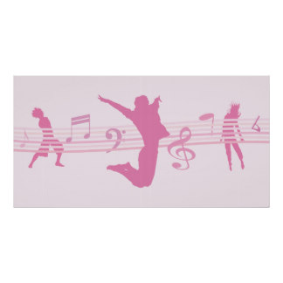
Physical Education: Dance
Year 1

Physical Me:  To become more physically skilful and competent in dance actions | Creative Me:  To become better at making decisions independently and with others about composition and developing phrases (motifs) | Healthy Me:  To take part in a more physically active and healthy lifestyle through increased health, fitness, confidence, motivation, knowledge and understanding | Thinking Me:  To be able to peer and self assess to bring about improvement in myself and others
I can respond to different stimuli with a range of actions. | I can choose movements to make into my own phrases (motifs) with beginnings, middles and ends. | I know where my heart is and understand why it beats faster when exercising. | I can use simple dance vocabulary to describe movement.
I can copy simple movement patterns from each other including the teacher and explore the movement. | I can practise and repeat their movement phrases (motifs) and perform them in a controlled way. |  | I can talk about dance, linking movement to moods, ideas and feelings.

