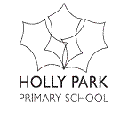

Assessment at Holly Park 2015-16

A guide for parents

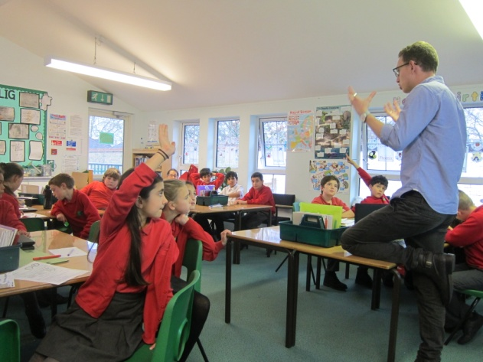
Following the introduction of the New National Curriculum for Key Stage 1 and Key Stage 2 last year, the government has now removed the system of levels that you will have been familiar with in terms of measuring progress and attainment.
Children will now be assessed one year at a time rather than moving through different levels year on year.
Schools now have their own systems which then align to end of key stage tests.
This leaflet is designed to give you more information about the new system for 2015-16.
Children’s progress is closely monitored at Holly Park. All assessment activities aim to ensure that the children are able to make progress in their learning whilst taking into account the needs of individual children.
The aims and objectives of assessment in our school are:
- to enable our children to demonstrate what they know, understand and can do in their work;
- to allow teaching teams to plan work that accurately reflects the needs of each child;
- to help our children understand what they need to do next to improve their work;
- to provide information for parents that enables them to support their child’s learning;
- to contribute towards accountability data.
- To be useful, purposeful and robust while at the same time not adding unnecessarily to teacher workload
We have a consistent approach across the school so that staff can have a comprehensive picture of where children are at each stage of their learning
Both tests and teacher assessment are necessary in order for the teacher to have a complete picture of a child’s capabilities.

Ongoing Teacher Assessment
Most formative assessment information will be collected through observations of children, work in books, discussion with children, guided group work, pupil self-assessment and, class quizzes, etc.
Assessment information will be used to inform teacher planning and to identify children who may need extra support or reinforcement.
At Holly Park we do not believe in a fixed mind set but rather support the idea of a ‘Growth mindset’ with opportunity for all pupils to succeed if taught and assessed effectively.

Assessment will involve:
- Learning objectives and success criteria made explicit and shared with pupils
- Learning partners are used and changed weekly to support learning
- Peer and self-assessment is in use verbally and in written form.
- Pupils are engaged in their learning and given speedy feedback during the lesson and in marking
- Active learning is encouraged
- A range of rich questioning techniques are used to evaluate pupil understanding and move learning on and identify misconceptions
- Children are given 3 levels of challenge to choose an appropriate level of work that best suits them.
- Use of our Holly Park Learning Skills to ensure we are assessing skills and understanding as well as knowledge.
- Pupil learning journeys so that children can easily see the expected learning objectives across all subjects in their year group and are involved in evaluating their own success and next steps
- Use of Assessment weeks to support teacher assessments and to identify gaps and misconceptions. Commercially bought tests are from reputable companies and administered in line with test protocols.

Pupil learning journeys (which include objectives for the year group) can be found on the school website for each year group.
If children meet all of the objectives for their year group they will be given challenges and opportunities to show learning at a greater depth and across different contexts. This is ‘Mastery’
Mastery is only able to be shown towards the end of the year when the full curriculum content for the year has been delivered.

How will information be reported to parents?
At parents evening you will be told at that particular point of the year if your child is expected, below or above for where they should be at that time. Of course teachers will talk to you about your child’s strengths and most importantly any areas for development that they can work on to move them on.
In Years 1-6 children are assessed against the following descriptors:
- Emerging - At early stage of development in the objectives for a specific year group
- Developing in the objectives for a year group (prompting needed) This is below the expected standard of depth of application and understanding.
- Secure - Exhibits skill with the objectives independently. This is the expected standard of depth of application and understanding with average application of learning.
- Greater Depth - Exhibits skill spontaneously and with confidence either above the expected standard with depth of application and understanding with a Good application of learning

The Expected positions for children each year are:
Autumn | Spring | Summer
Emerging | Developing | Secure

Your child’s attainment will be reported to you in the final end of year report in Reading, Writing, and Maths as being:

Below expected for the year group = Working towards the expected level
At the expected level for the year group = At the expected level
Above the expected level for the year group = Working at greater depth

It is anticipated that only the top ten percent of children each year will be working at greater depth.

The school can then track progress and attainment in a consistent manner to measure a child’s learning against the expectation for the year group they are in.

Statutory Assessment
Children at Holly Park undertake the following:

Early years

Baseline - At the start of the academic year in Reception and Nursery, staff assess where the children are at and identify next steps in learning. Throughout the year, Nursery and Reception staff will informally monitor development and keep detailed records that include photographs, post it notes of observations and more detailed learning journeys. Parents are also encouraged to contribute to the special books. This book and its contents are shared with families. Over the course of the academic year children in Reception are assessed against certain criteria. At the end of the year pupils are given a final assessment, a Profile score of 1 – working below expectation, 2- expected, 3- working above expectation.

Key Stage 1

Year One phonics check
All children in Year 1 will participate in a phonics check towards the end of the year. This assessment will be administered by the Year 1 teachers. It is a light touch assessment to confirm whether children have learnt phonic decoding to an appropriate standard. Results are included within the Year 1 end of term report.

Year 2 National Assessment
Children in Year 2 are assessed during May with National Assessments in English and Maths to establish what they have learnt during Year 1 and 2. The results of these assessments are reported annually to parents. In 2016 there will be a new series of assessments based on the new curriculum. Children will be assessed in Reading, Maths, Writing, Spelling and Grammar tests. Children will be deemed to be:
- Not working towards the expected standard,
- Working towards the expected standard
- Working at the expected standard
- Working at greater depth within the expected standard
The tests will be marked using a scaled score with 100 being expected.

Key Stage 2
Year 6 National Assessment
Children in Year 6 are assessed during May with National Assessments in English and Maths to establish what they have learnt during Years 3, 4,5and 6. The results of these assessments are reported annually to parents. In 2016 there will be a new series of assessments based on the new curriculum. Children will be assessed in Reading, Maths, Writing, Spelling and Grammar tests. Science will be teacher assessed.

For Reading, Maths and Science children will be deemed to be:
- Working at the expected standard
- Not meeting National Standards

For Writing children will be deemed to be:
- Not working towards the expected standard,
- Working towards the expected standard
- Working at the expected standard
- Working at greater depth within the expected standard

The tests will be marked using a scaled score with 100 being expected.

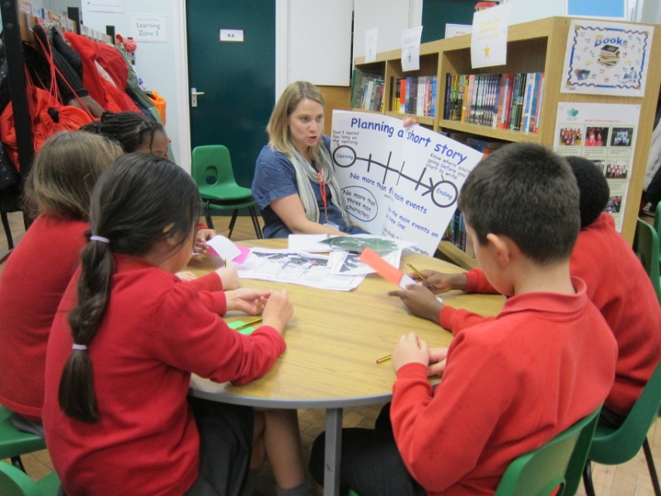

We hope that you find this guide useful in helping you understand how assessment has changed and how we will be sharing this information with parents and carers.

It is also worth noting that the expectations in the New National Curriculum are pitched at a much higher standard than previously and this will affect a child’s assessment measures.

