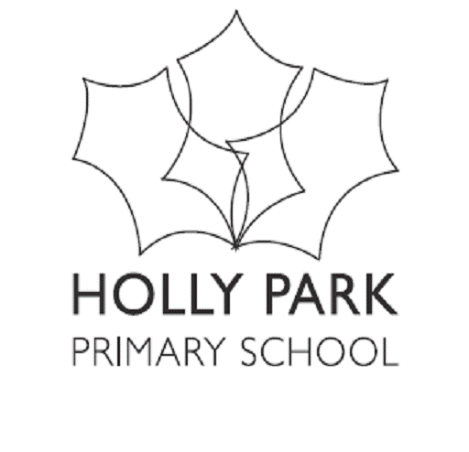Holly Park School – Finance Committee Meeting Date– 19th June 2017
Those Present- Ann Pelham, Maria Michael, Andrew Pearson, John Harte, Michael Crooks, Janis Hassan
Apologies -
AGENDA ITEMS | KEY DISCUSSION POINTS | ACTION (who? /timescale?)
Actions from previous meeting  - School Budget & year end  - School Meals Accounting  3. Special Fund  - Private Funds  5 Pupil Premium Money  6. Capital Expenditure  7. Breakfast Club  8. Policies to be ratified  - Governor allowances  - Use of debit cards  - Green procurement  9. . Any other business | - Swimming money: Look at this again in September. Janis will see how many people have paid this term and report back at the full governing body meeting  - Utility bills: Completed. No savings available. This year costs are lower. Possibly because of new lighting system  Ann advised next term partnership schools will collaborate and join forces to look at savings  - Dinner money debts: Andrew advised one parent has paid and no success on the other two. Andrew advised HPS cannot charge a fee for chasing up the payment.  - Marketing for nursery: Hedley will take photos and another parent will do the artwork. Mrs Pelham advised that out of the 52 places available in nursery next term, 50 children are booked for the morning session, 35 for the afternoon. Ann advised that there is a problem with the new Government website (may be specific to Barnet). The school is not able to check the 30 hours per week code which means some places may be withdrawn.  - Janis explained the outturn various savings 21k carry forward. Mrs Pelham will use some of the money for an extra member of temporary staff, for PP children. Rob has not spent the IT budget for last year, therefore £4000 from last year and £4000 from next year will go new Google Chrome Books.  A governor queried the compassionate leave spend as it was 180% of budget. Janis advised this report shows very little spend due to the timing of the report  - Current debts are summarised as;  - 4 between 20 – 30  - 11 between 30 and 40  - 2 between 60 – 70  - 3 between 40 – 50  One Y6 child owes £96 plus £350 for school journey.  A governor suggested paper reminders, Janis advised that they are been already sent when the debt reaches a certain amount.  Going forward, HPS may suggest voluntary contributions to increase revenue. BV suggest lottery style competition  - No update  - Private funds have been moved into the HPS current account. Private fund will be kept for props, costumes and flowers for staff. The balance is £2200.  - All pupils were provided access to either Spellodrome, Reading Eggs or Mathletics. The budget for HEWS has been doubled.  - Capital expenditure is £10,000, school will redecorate some offices and classrooms, three quotes have been requested and will be presented at the full body governor meeting.  - Breakfast club is looking good with only 9 debts, school is now taking a hard-line only allowing a debt of £7.50 before the child is refused entry.  - Some comments of green procurement policy before final approval.  - No other business | Janis  Janis / Ann

