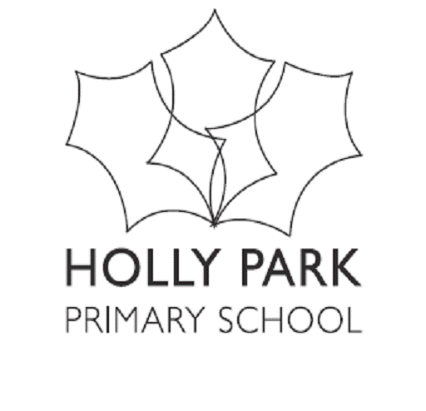

Bellevue Road, Friern Barnet, London N11 3HG
t: 020 8368 1434 f: 020 8361 6329 e: office@hollypark.barnetmail.net
www.hollyparkschool.co.uk

July 2017
Dear Parents and Carers,
Staffing for Next Year:
To help show which teacher will have which class, we have shown the children’s current class in brackets.

Nursery:
Miss Wood, Mrs Elia and Miss Mornington

Reception:
Palm Class: Mrs Moore, Mrs Walton, Mrs Bawcombe & Miss Yianakki, Miss Klanga, Miss Rush,

Year 1
Pine Class: Mrs Casey
Chestnut Class: Mrs Mir

Year 2
Elm Class: Mr Turner (teaching this year’s Chestnut Class)
Rowan Class: Mrs Fitzpatrick (teaching this year’s Pine Class)

Year 3
Hazel Class: Mr Bourne
Willow Class: Mrs Mehtar

Year 4
Mulberry Class: Mrs Tsenti (teaching this year’s Willow Class)
Sycamore Class: Ms Owen (teaching this year’s Hazel Class)

Year 5
Maple Class: Mr Carini (teaching this year’s Mulberry Class)
Juniper Class: Mr French (teaching this year’s Larch Class)
Hawthorn Class: Miss Mountford (teaching this year’s Sycamore Class)

Year 6
Beech Class: Miss Biggs (teaching this year’s Juniper Class)
Cedar Class: Mr Stewkesbury (teaching this year’s Maple Class)

Yours sincerely,
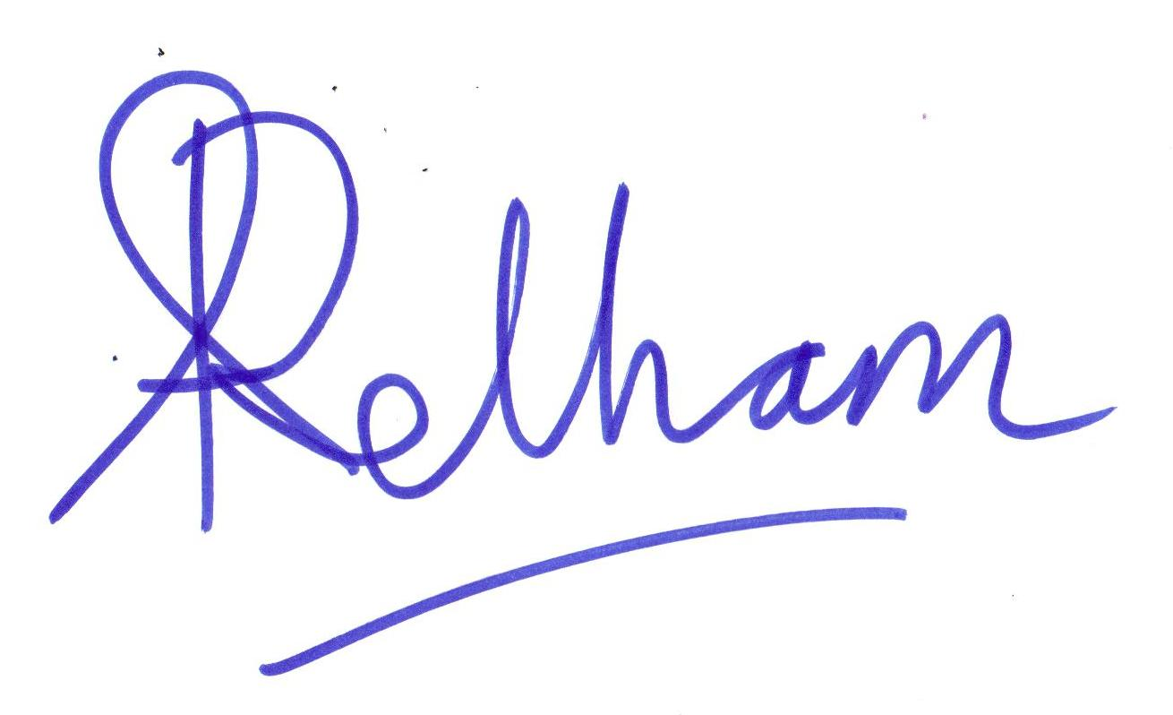
Ann Pelham
Headteacher

