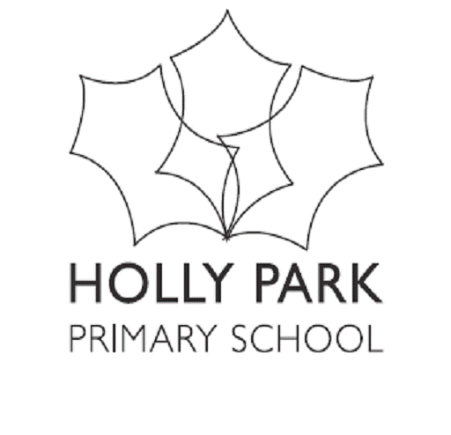

**Bellevue Road, Friern Barnet, London N11 3HG**

t: 020 8368 1434 f: 020 8361 6329 e: office@hollypark.barnetmail.net

Friday 10th March 2017

Dear Families,

I am writing to let you know that Barnet Local Authority have asked us to take on a bulge class in September 2017. The Holly Park governors have agreed to this.

The new bulge class will begin in Reception Class and will then move up through the school with three classes. Obviously this is not the first time that this has happened at Holly Park and we are experienced at managing bulge classes within the school. At present we have two bulge classes – one in Y6 and one in Y4. In July our current Y6 bulge class will leave us and move on to secondary school. By gaining a new bulge class in September, our school size will not alter from what it has been in the last five years.

There is a need for school places that the Local Authority has identified in our local area. The Local Authority has a legal duty to offer places to all school-aged children who live in Barnet that wish to have a place. The local authority is not obliged to consult with governors or parents to increase the capacity of the school by less than 25% or 200 pupils.

At Holly Park we are very fortunate to have such a strong set of experienced staff. Staff mobility is very stable and hardly any members of staff have left in the last couple of years. With the Y6 bulge class leaving in July and no suggestion of any teachers leaving us (at this point) we would have had to begin procedures for making a teacher redundant in July had we not been given this bulge class for September.

There should be little effect on the rest of the school by having a new bulge class as the two bulge class in September will be in separate parts of the school (Reception and Y5). They will both be in separate playgrounds, eat lunch at completely separate times and Reception do not attend assembly. This is a one off bulge class for September 2017 and does NOT mean we are expanding to be three form entry throughout.

I will be writing a separate letter (in more detail) to the parents currently in nursery and to those who will join us in Reception new to Holly Park.

Yours sincerely

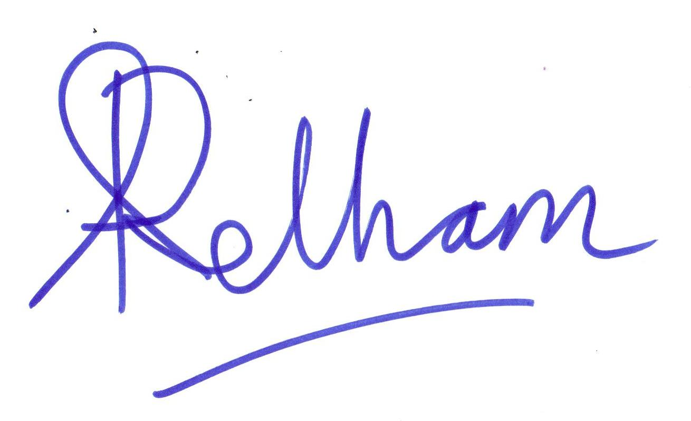

Ann Pelham Andrew Ballam Davies

Headteacher Chair of governors