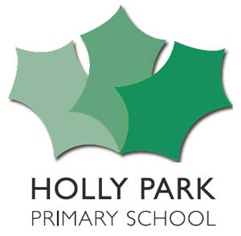

Learning Council
Notes of meeting
Friday 5th May 2017

In Attendance – Mrs Pelham, & learning council members

- Mrs Pelham welcomed the learning council
- Mrs Pelham told the council that today they would be looking at behaviour in the school and visiting classrooms to see behaviour and would be discussing what makes good behaviour in lessons.
- Mrs Pelham asked the council to think about ‘What makes good behaviour in the classroom.’ In pairs the council discussed it and came up with:
Participating in lessons
Listening to the teacher and each other
Producing a good amount of work in the time
Not giving up –showing resilience
Joining in discussions – whole class & learning partners
Trying your best
Co-operation
Using the Holly Park Learning Skills
Following class charters
Supporting others
Being on task
Talking about the work
- The council went around the school from Nursery to Y6 to look at behaviour
- They reported back that they saw – most of children doing the right thing, age appropriate activities, good creativity, tidy classrooms, fun learning, children working together, children doing as they were told, children enjoying themselves, children smiling and happy, medium noise levels, listening to the teacher, children concentrating, children sharing, children on task.

Action

- The council will report back to the whole school about the positive behaviour they saw on Monday 8th May

