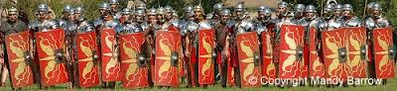
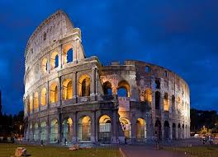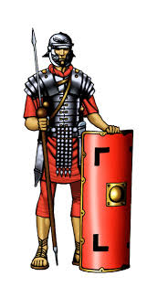ng Project
The Romans

Dear Parents/Carers,

Welcome to the Spring Term in Year 3. Our Learning Project this term is all about The Romans. Please see below for how this links to different areas of the curriculum.

Best wishes,
E Mehtar and N.Bourne

English | Maths Science |  | Art & Design
Instructions  Reports on Roman Army  Letters from Roman Soldiers  Speeches - Boudicca | Multiplication  Division  Measurement | Food Groups  Food Chains  Skeletons  Muscles  Grouping animals with/without skeletons | Design  Roman shield  Design Roman mosaics
Design & Technology | PSHE | Computing | History
Levers and Pulleys | I can make good food choices  I can identify, reflect on and celebrate my achievements/ strengths | To use sequence in programs  To use selection in programs  To use repetition in programs  To work with variables | Founding of Rome  Roman army  Roman soldiers  Roman invasion of Britain
PE | Spanish | Music | Visits and events
Tag Rugby with Non Stop Action  Indoor PE – Dance –Roman Dances  From Feb Half Term -Swimming | Classroom objects  Weather  Colours  Alphabet  Numbers 1-30  Euros and pounds  Easter and chocolate | Cornet project  Traditional notation  Pentatonic scale  Chinese New Year | Tag Rugby with Non Stop Action

Requests: We begin swimming after Spring Half Term. We need parents to be able to walk the children to and from the pool. If you are able to assist on Wednesday afternoons please speak to the Year 3 teachers

