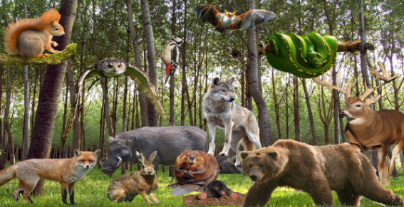
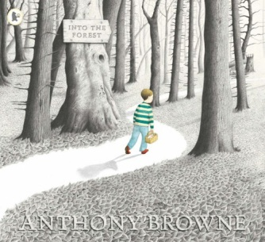
FOREST FRIENDS

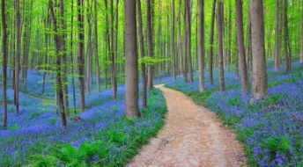
Dear Parents/Carers,
Welcome to the Summer Term! Our Learning Project focus for this term is on forests. We will be studying a lot of science and geography as well as working on some excellent texts, all linked to our Forest theme. The project of forests gives us an opportunity to investigate different habitats and how animals adapt in different environments. We will also be having a focus on environmental issues and understand our role in sustainability and being environmentally friendly.
See below for further information on how different subject areas will be covered over the term.
Best wishes,
Mrs Bawcombe, Mr Carini, Mrs Cozens and Mrs Tsenti
English | Maths |  | Science
We will be focusing on reading comprehension and improving our writing through the use of quality texts.  A Midsummer Night’s Dream  Mouse, Bird, Snake, Wolf  Into the Forest | Time  Decimals and money  Measurement – perimeter and length  Angles | Shape and Symmetry  Position and direction  Statistics  Area and Perimeter | Evolution  Changing Habitats and adaptation  In science week: Materials and Electrical Circuits
Art & Design | Geography | RE | PSHE
Collage | Forests around the world | Sacred Texts | The Environment
Computing | History | PE | Music
Coding  Digital Literacy | Vikings and Anglo-Saxons (struggle for the Kingdom of England to the time of Edward the Confessor) | Dance  Athletics  Gymnastics  Tennis | To develop an understanding of the operatic genre  To select and combine sounds and understand that mood and emotion can be illustrated in music. To revise and refine choral singing
Spanish |  | Other Events
To say the weather in Spanish  To name different fruits in Spanish  To learn the days of the week  To read the book: The very hungry caterpillar.  To say food and drinks in Spanish  To recognise and apply simple agreements, singular and plural, male, female  To read a restaurant menu  To ask for the bill and pay |  | 21.4.17 Project Britain day  15th May Enabling Enterprise Week  16th May – Mulberry Class Assembly  19th May Summer House Challenge  6.6.17 Online Safety Day  12th June Bike Week  16th June International Charity Event  19th June Holly Park: Science Week  20th June Class Photos  28th June Y4 Review for parents at 2.30pm  7th July Junior sports  To be confirmed...  Wednesday 12th July and Friday 14th July – Educational visit (45 children on each day)

Other Information:
For the first half term Year 4 have the non-stop action coach and PE will take place on Monday. In the second half term Mulberry and Sycamore PE time will return to Thursday and Larch will return to having their PE on a Friday.

