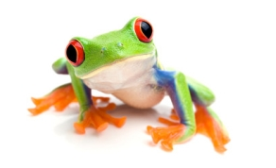
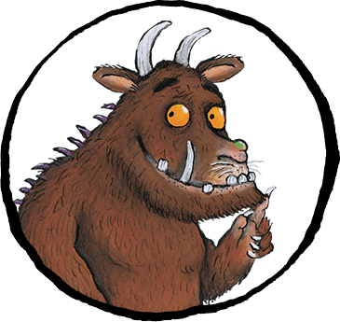
There’s No Such Thing as a Gruffalo
And
rainforests

Dear Parents/Carers,

Welcome to the Spring term in Year Two. Our Learning Projects this term are all about books by Julia Donaldson and The Rainforest. Please see below for how these link to different areas of the curriculum.

Best wishes,
Lewis Turner and Emma Fitzpatrick

English | Maths |  | Science
Books by Julia Donaldson  rhythm and rhyme  patterned stories  story writing  information writing  poetry | addition and subtraction  multiplication and division  measure  time  shape | fractions  problem solving | sound  living things – plants and animals  life cycles  habitats
Art & Design | Design & Technology | RE | PSHE
colour mixing  shading  tints and tones  patterns | moving pictures  winding mechanisms | leaders  people who help us  special people | identifying feelings  managing feelings  circle times
Computing | Geography | PE
writing algorithms  debugging algorithms  e-safety | locating the rainforest  comparing localities  geographical features | dance – creating movements  games – rules, making up games, healthy circuits
Spanish | Music | Visits and events
Fruits  Colour revision  Days of the week  Greetings  Weather  The hungry caterpillar  Parts of the body  Chocolate & Easter | Infant Show songs  Rhythm and notation  Exploring Pitch | Synagogue  Kew Gardens  Friern Barnet Library

Other Information:
If you would like to come on any trips, please make sure your DBS check has been done at the office.

Key Dates:
23rd/27th Jan – Y2 Assessment Meeting
1st Feb – Y2 SPAG workshop for parents
7th, 8th and 9th February – Infant Show, you should have received a letter about this in your child’s book bag.
More information regarding trips will follow nearer the time.

Requests:
Please bring in any shoe boxes that you may have.

