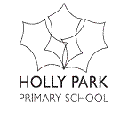 Holly Park School
Behaviour Policy

At Holly Park School we aim to provide a learning environment in which children can achieve their maximum learning potential.

We believe it is the right of all children rergardless of gender, ethnicity, age, physical or academic ability, cultural or home background, to have access to quality learning experiences in a safe, secure and supportive environment.

Children need security, consistency, praise and encouragement if they are to develop a positive self image and be able to achieve. We aim to teach our children how to behave appropriately so that they become responsible social people within our school and within society.

Links to the UN Rights of the Child
Article 3
The best interests of the child must be a top priority in all things that affect children.

Article 4
Governments must do all they can to make sure every child can enjoy their rights.​

Article 28
Every child has the right to an education. Primary education must be free. Secondary education must be available for every child. Discipline in schools must respect children’s dignity. Richer countries must help poorer countries achieve
this.​​

The following document outlines Holly Park’s Behaviour Plan in detail.

- Aims and Objectives

Aims
- At Holly Park School we aim to promote a pleasant and respectful attitude in all our pupils, with emphasis on self discipline, respect for others their opinions and property, and courtesy and good manners. We aim to enable all pupils to behave in a way that shows respect for themselves and others
- We are committed to working in partnership with parents and outside agencies in creating a happy, balanced, caring and safe environment in which our pupils can thrive and achieve success.
- To help all children develop a sense of right and wrong, to develop an understanding of the consequences of their actions and to take responsibility for their actions
- To support children in accepting and following school rules
- At Holly Park, we endeavour to ensure that staff work together to maintain high standards of behaviour. All members of staff are supported and valued.
- Our aim is to be positive - to praise good behaviour and to be fair.
Objective
- To promote respect for others and for school property
- To set high expectations of all children
- To promote pride in the school environment
- To ensure children move safely round the school
- To value diversity
- To promote positive behaviour and deal with unacceptable behaviour
- To give positive reinforcement whenever possible
- To ensure the emotional and physical safety of everyone in our school

2. Principles

2.1 Holly Park combines high expectations for educational progress with equally high expectations of behaviour. We base our policy upon the positive reinforcement of good behaviour, promoting self-discipline and a proper regard for all adults amongst the pupils.

2.2 We expect all members of our community to display good manners and respect for others. This includes holding doors open for others, saying ‘please’ and ‘thank you’ at the appropriate times and following the school code of conduct at all times. We aim to remind our pupils of the Code of Conduct frequently.

2.3 We acknowledge that without good standards of behaviour and discipline, then high standards of academic and physical achievement and emotional development of pupils at Holly Park would be impaired.

2.4 The use of Circle Time, positive rewards and an approach that looks at how we can move forward together in a positive way after any unacceptable incident (Solution Focused Approach and Restorative Justice) are intrinsic to our management of behaviour.

2.5 By consciously and consistently promoting an atmosphere of good behaviour, the likelihood of poor behaviour is lessened. There is a regular and consistent emphasis on the positive recognition and reward of good work and behaviour. The rewards and sanctions used to provide for the recognition of good behaviour and the punishment of bad behaviour are set out in the appendices.

3. The Code of Conduct

3.1 Our Code of Conduct is integral to all we do at Holly Park. The children are taught to treat everyone in our school with respect and fairness. We also have a clear system of consequences should a child not behave appropriately. Consequences or sanctions range from a reprimand to time out and missed time for fun at playtimes with friends. Should children misbehave repeatedly we would endeavour to solve the problem in partnership with their parents. In extreme cases the Headteacher has the right to exclude a child for a period of time, these exclusions may be internal, external or just over the lunchtime period.

3.2 Our code of conduct for all members of the Holly Park community – pupils, staff, parents, governors and visitors is:

    - We are all respectful towards each other
    - We take responsibility for our actions
    - We treat others with kindness and care
    - We maintain a positive attitude
    - We try hard in all that we do.
    - We are honest

This code should be reviewed termly in assembly

4. The Holly Park Way 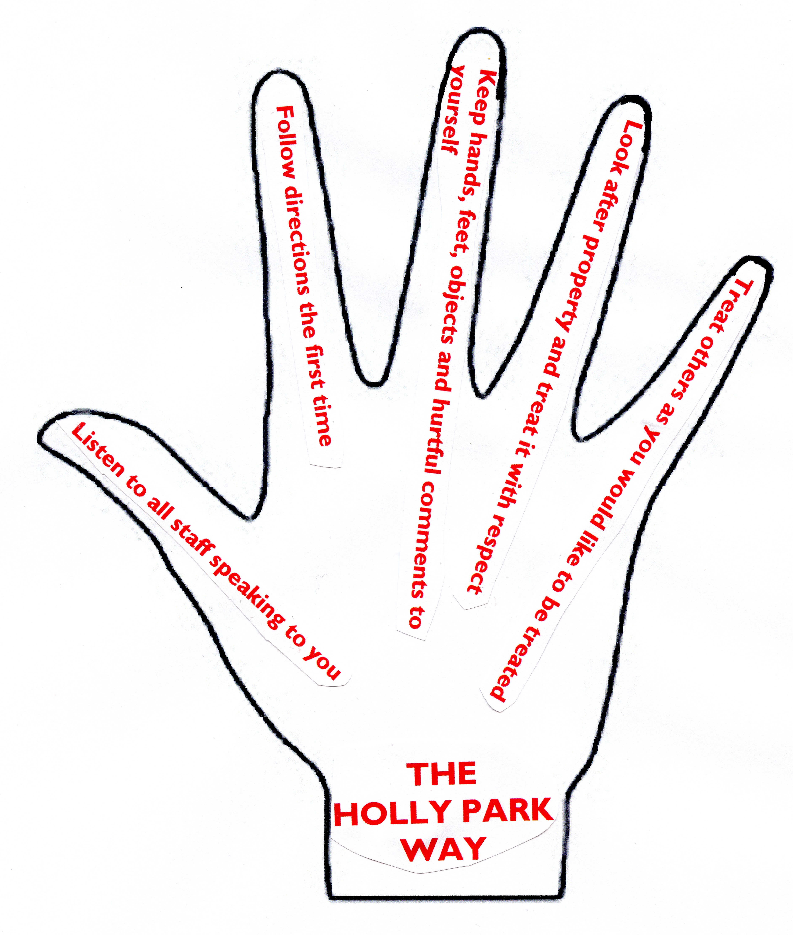

There are 5 clear rules that apply at all times and in all places

- Listen to all staff speaking to you
- Follow directions the first time
- Keep hands, feet, objects and hurtful comments to yourself
- Look after property and treat it with respect
- Treat others as you would like to be treated

The Holly Park Way should be displayed around the school and children should be reminded of it regularly in assembly

5. Class Rules

5.1 At the beginning of each year, class teachers discuss the Code of Conduct and The Holly Park Way with their classes, and draw up a list of Class Rules. These Classroom rules link with the Code of Conduct and should be written in child appropriate language. These rules support the Code of Conduct by identifying their relevance in terms of age and experience to each of the classes.

  - The Code of Conduct, The Holly Park Way and the Rights Respecting Class charters should be displayed clearly in classrooms, and are used as a tool for managing behaviour.

These rules should be reviewed half termly in the classrooms.

6. Positive Reinforcement of Good Behaviour

6.1 Children receive regular and justifiable praise in all classrooms and during the Celebration Assemblies, for good work, behaviour, attitudes, thoughtfulness towards others in school and also for activities and behaviour within the home, community or neighbourhood.

6.2 Certificates, stickers and House Points are given and children are also sent to the Headteacher and Senior Staff for encouragement and reward. Excellence in all areas of the children’s development is praised and rewarded. The purposes of the different rewards used at Holly Park are given in Appendix B.

6.3 On entry to the school, each child is allocated to one of the five school houses: Unicorn, Hydra, Griffin, Dragon and Phoenix. House points are collected on a Friday and the house with the highest number of team points wins the House Cup for that week. The house with the highest total of points at the end of the year will be awarded the House Shield.

6.4 Whole class achievement in behaviour is rewarded by use of a marble jar. When the whole class have behaved exceptionally well, they will have earned a marble. Once their marble jar is full (varying amounts for each phase of the school), they will participate in an agreed activity (negotiated by the teacher with the whole class at the beginning of the marble collection process).
Foundation Stage: Ten marbles
Key Stage One: Twenty marbles
Lower Key Stage Two: Thirty marbles
Upper Key Stage Two: Forty marbles

7. Sanctions/Consequences

We consider the following types of behaviour to be unacceptable:
Racism Name calling Homophobia Bullying Physical aggression Refusal to work Refusal to obey school rules Severe disruptive behaviour

7.1 Unfortunately there will be the need for sanctions. The staff have identified different categories of misdemeanour, and appropriate sanctions have been matched to these categories (see Appendix A).

7.2 Sanctions should be applied fairly and consistently to all pupils, according to the agreed ‘staged’ approach (see appendices), and within a context of positive reinforcement of good behaviour. Some pupils have their own Individual Behaviour Plans and these should be applied to them.

7.3 Parents will be kept informed if their child’s behaviour is showing cause for concern, and may be called in if the behaviour does not improve. Contact may be made through phone calls or a simple chat at the end of the school day.

7.4 Time out is used as part of our planned behaviour programme. Time out is either within the classroom, in another classroom, in an area of the playground or in an office. Time out is NOT seclusion. The individual in time out will be monitored and not left alone.

8. Giving children strategies to cope with unacceptable behaviour
We want to teach our children the skills which will build their self-esteem and empower them to take responsibility for themselves and give them the power to practise these skills.
We want to promote pro-active strategies for when children are on the receiving end of unacceptable behaviour, conflict or aggression. If someone upsets or hurts them they should:
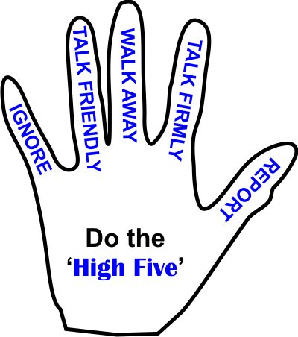Do the Hi 5:-
- Ignore
- Talk Friendly
- Walk Away
- Talk Firmly
- Report

9. Individual Behaviour Plans
Some children have more specific behaviour needs and may present persistently challenging behaviour. For a variety of reasons they may find it difficult to follow our school code of conduct. An Individual Behaviour Plan will be set up for any child where there is an identified need for support when their needs cannot be met by the common approach of the school. The plan seeks to provide individualised sanctions and rewards in line with the whole school approach. This plan will have individualised strategies which may include a home/school liaison book, a daily sticker chart and specific mentoring sessions. The plan is agreed by the class teacher, Headteacher or Deputy Headteacher, Children’s Co-ordinator and parents. There is generally some intervention or advice by external agencies in making the plan. An individual plan may be drawn up when a child has a Statement of Special Educational Need that may relate to behaviour, has had a fixed term exclusion or for a child who is at risk of failure through school disaffection. Individual Behaviour Plans for pupils are shared with everybody who may need to be involved. The Individual Behaviour Plans will reflect appropriate strategies to meet the child’s additional needs. Parents will be regularly informed of progress against it.

Our Pastoral team also meet weekly to discuss high level incidents or pupils of great concern. They make an action plan andn this is reviewed the following week.

10. Restorative Justice

10.1 At Holly Park Senior leaders, Our Learning Mentor and Class teachers often use Restorative Justice techniques when dealing with the consequences of unacceptable behaviour. Restorative justice can be defined by its fundamental principle, namely that when one person has harmed another, the most useful response is to try to repair the harm done.

10.2 Restorative justice in schools aims to reduce bullying, manage conflict and improve attendance in schools; research evidence supports restorative justice in schools as a particularly promising approach to improving behaviour and attendance.

10.3 Restorative justice enables pupils affected by bullying, or other serious behavioural incidents, to communicate and agree on how the harm caused by their actions or done to them is to be repaired. When well-implemented, perpetrators learn to understand the consequences of their behaviour and take responsibility for repairing the harm. When this happens victims usually experience the perpetrator’s commitment to reparation which means their fear of re-victimisation is reduced and they are more readily able to put the incident behind them.

10.4 Restorative justice in schools may involve holding discussions between the perpetrator and the victim with a mediator. School staff often use restorative approaches more informally in dealing with minor behaviour problems.

11. Teaching Responsible Behaviour
Teachers have a right to teach and children have a right to learn.

11.1 We recognise that;
- an effective and stimulating curriculum;
- differentiation which challenges, engages and stimulates;
- identified learning objectives and outcomes for each task;
- clear and appropriate expectations;
- good classroom organisation and management;
- consistent and clear routines
- constructive and positive feedback
are all crucial to the continued atmosphere of good behaviour at Holly Park in and around the classroom.

11.2 Staff should use effective techniques:
- Be calm, firm and positive
- Give clear specific directions for activities
- Have consistently high expectations of children for both learning and behaviour

11.3 When behaviour is off-task staff should use
- A look
- Praise the pupils nearby doing the right thing
- Say the child’s name

11.4 For more disruptive behaviour staff should take pupils aside and ask:
- What they did that was inappropriate
- What they should do differently
- What is expected next time

11.5 Staff should lower their voices to get attention or when reprimanding. Shout only in violent situations or when necessary to startle and gain attention quickly. Have a clear cue to gain attention – e.g clapping, counting -3,2,1 etc

11.6 Classrooms should always be tidy, attractive and have up to date displays. Staff should make clear to pupils what is expected of them. Staff should try to diffuse possible situations before they occur and continually observe and scan the behaviour in the classroom. Staff should always listen to pupils.

11.7 At Holly Park pupils will be taught about responsible appropriate behaviour. This will be done through:
- Circle times allowing children to discuss behaviour
- Classroom activities involving PHSE, art, drama, role play and discussion
- During assembly
- Modelling good behaviour
- Consistently reinforcing good behaviour
- Ensuring that children understand that their behaviour affects themselves and others in the school
- Redirecting inappropriate behaviour
- The school Council reviewing the behaviour policy annually
- The Learning Council discussing Learning Behaviour within the classroom

11.8 Staff recognise that praise is a powerful tool for developing confidence, raising self esteem and positive appropriate behaviour. At Holly Park we aim to develop a warm, welcoming, positive ethos by use of praise. We aim to:
- Greet pupils each day in a positive way
- Praise each child in some way during a school day
- Smile when we praise
- Use terminology such as ‘Thank you for…., I like the way you….’
- Use children’s names when we praise to show we values them as individuals
- Be specific in our praise e.g ‘Thank you Joe for tidying up so well.’

11.9 In class children should come in and out in an orderly manner. They should address staff by their name and they should ask permission to leave the room so the teacher knows where they are. (except in EYFS where the toilets are situated within the learning environment)

12. Playtimes, Lunchtimes, Assemblies and moving round the school

12.1 The same rules apply at playtimes and lunchtimes. The school is committed to making playtimes and lunchtimes as positive, safe and enjoyable as possible. Mealtime supervisors are employed by the school to support and supervise the children as they eat and as they play at lunch. They also run a variety of activities for the children. Our Learning Mentor is on duty at playtimes and lunchtimes. The Learning Mentor and The Senior Mealtime Supervisor are the first point of call for any behaviour issues at lunchtime. Every lunchtime a member of the Senior Management team is on duty. Repeated instances of challenging behaviour may result in a pupil being temporarily excluded from staying at school through the lunchtime period. However, children should also be praised and acknowledged by supervisory staff for playing well and showing respect and kindness.

Children should follow the playground rota for use of designated areas. Children should only enter the building to go to the toilet or to collect a coat or lunch bag. Children should follow the routine for the end of playtime – move line up on the bell.

Adults should defuse potential incidents or situations whenever possible. They should continually observe and scan the behaviour in the playground. They should be in the designated area as defined by the duty rota. Adults on duty should not be talking with each other. Adults should apply the school rules. Adults should listen to children always listening to all sides of a story before reaching any decision.

Lunchtime Rewards and Sanctions
Our rewards and sanctions follow the same rules as in our behaviour policy for lesson time (see behaviour policy)
We expect the same standard of behaviour at playtimes as during lesson time
House points are awarded for good behaviour – e.g holding a door open, picking up some litter etc
At lunchtimes, the MTS give out golden raffle tickets for good behaviour. Children then take these back to class and write their name on. Each ticket earns them a housepoint.
Every raffle ticket is put in the golden box for the class. At the end of every half term a raffle ticket is drawn out of each golden box in an assembly and the winners are given a special treat. The more raffle tickets a child has in the box the greater their chance of being drawn out.
There is also a special golden book for very special behaviour or acts of kindness. Names can be written in this book and the names will be read out in assembly each week.
The MTS can also add names to a class book for any children whose behaviour is of concern at lunchtime. There is a book kept in each classroom.

12.2 In assembly we expect pupils to continue to follow the school behaviour policy. We also expect pupils to sit legs crossed, lips closed and eyes to the front keeping hand and feet to themselves.
Each class teacher needs to leave enough time to prepare children for assembly. They should walk with the children ensuring they are quiet. Take responsibility for the behaviour of their class during assembly – catching their eye and moving them near an adult if necessary. They should ensure children enter and exit in silence. All staff should act as positive role models and set a good example of appropriate assembly behaviour.

12.3 When moving around the school children should always walk and should move about quietly.

Adults should remind the children of our expectations and give praise for children or classes who do this well. Adults should stop their class line at points on the journey to check the children are together. Adults should remind children who are running to stop and walk.

13. Equal Opportunities

We have an Equal Opportunities Policy which underpins all our other guidelines and polices. We actively oppose racism and aim to promote respect for others. Parents will be informed immediately if their child makes a racist comment or displays any other form of racist behaviour. All incidents will be recorded and school governors informed of serious harassment.

14. Incidents involving drugs or other harmful substances

The school has an anti-drug policy which reflects the interests of the whole school community. Advice from the local Drug Action Team will be sought following any incident in order to help support any pupil involved. (See PSHE policy).

15. Personal Contact

The following examples of contact are deemed appropriate for the staff and pupils
at Holly Park:

- Comforting and consoling children where appropriate and in a clear and open manner.
- Removing a child from danger or from hurting another child may need the restraining action of a staff member.
- Physical exercise - in a clear and open manner.
- In the swimming pool whilst learning to swim - life saving.
- Helping a child to change clothing i.e. a young child for P.E., or a child who has become unwell and needs changing.
- Treatment for injuries
- Resuscitation or other life saving procedures.

16. Bullying

The school has a separate Anti-bullying policy, but these key principles are intrinsic to our philosophy of behaviour management:

- All staff are firmly committed to preventing acts of bullying
- We have a school policy that is applied by all staff. Allegations of bullying are taken seriously and investigated
- Victims of bullying will be supported. No one deserves to be bullied even if their behaviour is irritating or annoying
- Through the curriculum, activities are planned to develop positive relationships and to discuss issues associated with bullying
- The school applies a range of sanctions which can lead to exclusion

17. The Role of Parents

In order for our Behaviour Policy to have maximum benefit for our children, it is vital to involve parents. Parents are:
- Involved in the plan through the sending home of certificates, sticker charts, badges etc
- Involved in the consequences of inappropriate behaviour through phone calls, discussions with staff and more formal meetings.
- Given information about their child’s behaviour at termly parent consultations and in the annual report
- Informed, as new parents, about the importance of the Behaviour Policy
- Given access to the policy through the school website
- Kept up to date on any whole school behaviour matters through the weekly newsletter
- Given opportunities to discuss the Behaviour Policy in general informally through regular coffee mornings

18. Extremism & Radicalisation

As part of Holly Park’s commitment to safeguarding and child protection we fully support the government's Prevent Strategy.
The Prevent strategy is a government strategy designed to stop people becoming terrorists or supporting terrorism. It:
- responds to the ideological challenge we face from terrorism and aspects of extremism, and the threat we face from those who promote these views
- provides practical help to prevent people from being drawn into terrorism and ensure they are given appropriate advice and support
- works with a wide range of sectors (including education, criminal justice, faith, charities, online and health)
As part of our safeguarding ethos we encourage pupils to respect the fundamental British values of democracy, the rule of law, individual liberty and mutual respect, and tolerance of those with different faiths and beliefs. We ensure that partisan political views are not promoted in the teaching of any subject in the school and where political issues are brought to the attention of the pupils, reasonably practicable steps have been taken to offer a balanced presentation of opposing views to pupils.

Radicalisation is defined as the act or process of making a person more radical or favouring of extreme or fundamental changes in political, economic or social conditions, institutions or habits of the mind.

Extremism is defined as the holding of extreme political or religious views.

There are a number of behaviours which may indicate a child is at risk of being radicalised or exposed to extreme views. These include;
- Spending increasing time in the company of other suspected extremists.
- Changing their style of dress or personal appearance to accord with the group.
- Day-to-day behaviour becoming increasingly centred on an extremist ideology, group or cause.
- Loss of interest in other friends and activities not associated with the extremist ideology, group or cause.
- Possession of materials or symbols associated with an extremist cause.
- Attempts to recruit others to the group/cause.
- Communications with others that suggests identification with a group, cause or ideology.
- Using insulting to derogatory names for another group.
- Talking about internet activity and websites that may involve radicalisation
- Increase in prejudice-related incidents committed by that person – these may include;
- physical or verbal assault
- provocative behaviour
- damage to property
- derogatory name calling
- possession of prejudice-related materials
- prejudice related ridicule or name calling
- inappropriate forms of address
- refusal to co-operate
- attempts to recruit to prejudice-related organizations

Although incidents involving radicalisation have not occurred at Holly Park School to date, it is important for us to be constantly vigilant and remain fully informed about the issues which affect the local area, city and society in which we teach. Staff are reminded to suspend any ‘professional disbelief’ that instances of radicalisation ‘could not happen here’ and to be ‘professionally inquisitive’ where concerns arise, referring any concerns through the appropriate channels.

19. Nursery
The nursery follow the ethos of this behaviour policy particularly with regard to praise and reward however they cannot follow all of the reward schemes we have or sanctions.
In Nursery children are rewarded through verbal praise and feedback to parents
If a child misbehaves in nursery then the following sanctions will apply:
- Children are spoken to and it is made clear why they should not behave in a certain way
- Parents are kept informed and the staff work in partnership with parents
- Children are encouraged to apologise to each other
- Thinking time may be used
- In cases of severe aggression or violence towards another child or member of staff then the child will be asked to miss a nursery session.
- If this aggressive behaviour continues then the child may miss up to a week of nursery at a time.
- The nursery staff will try to work with the parent and child to avoid further situations and support the child. However, as nursery is not a statutory part of schooling a child who is continually aggressive may be asked to leave the nursery.

20. Monitoring and Review

20.1 It is the responsibility of the Governing Body to monitor the effective deployment of this policy. This responsibility has been delegated to the Staff and Pupil Welfare Committee.

18.2 Annual training will be held to discuss behaviour issues as a school. Staff will attend courses on behaviour management as appropriate.

18.3 This policy will be reviewed on an annual basis.

Document Control

Revision History
Version | Revision Date | Revised By | Revision
1.0 | Autumn 2013 | Ann Pelham | Revised
1.1 | Summer 2014 | S&PW Committee | Amended, adopted & ratified
1.2 | Summer 2015 | S&PW Committee | Amended, adopted & ratified
1.3 | Summer 2016 | S&PW Committee | Amended, adopted & ratified

Signed by
 | Name | Signature | Date
Headteacher | Ann Pelham
Chair of Governors | Andrew Ballam Davies

Distribution
Shared with
- Staff via school server
- Parents via Website
- Governors via committee meetings

Date for next review
Summer 2017

Appendix A: Misdemeanours and Sanctions

Appendix B: Rewards

Appendix C: Letter of notification of unacceptable behaviour

Appendix D: Behaviour Alert Form for internal use
HOLLY PARK PRIMARY SCHOOL

Unacceptable Behaviours in the Classroom and their Sanctions

Behaviour |  | Sanction
Blue Level behaviours include or are equivalent to… |  | Blue Level Sanctions
- Not lining up well  - Talking out of turn or calling out  - Inappropriate noise  - Distracting others  - Throwing things  - Pushing |  | Managed by class teachers  One off use of behaviours:  The teacher will explain why their behaviour is inappropriate, they will deal with the incident effectively and immediately.  Acknowledge that inappropriate behaviour has occurred. React calmly, reasonably and fairly.  Attempt to identify the children immediately involved . Allow the child(ren) to give their side of the story. Remind children of the appropriate behaviour.  They may go to the class ‘time out’ table away from the main activity, for 5 minutes (KS1) or 15 minutes (KS2) | Repeated use of behaviours: Managed by class teachers  Continuous inappropriate behaviour will mean the child is sent to another class for ‘time out’. It is the class teacher’s responsibility to monitor this. Children who are persistently being given time out should be discussed with the Deputy Head, Inclusion Manager and / or Learning Mentor. Children should be sent with an adult or other child. The receiving teacher should show their disappointment.
Yellow Level behaviours include or are equivalent to… |  | Yellow Level Sanctions
- Deliberate shoving  - Inappropriate bad language including swearing  - Spoiling something that belongs to someone else  - Lying  - Teasing which upsets others  - Spitting  - Name calling  - Wrestling and play fighting  - Kicking, slapping, punching or biting  - Disobedience and rudeness |  | One off use of behaviours:  May be Managed in class – thinking time, time out  May be sent to a Key Leader. Playtime or lunchtime may be missed. | Repeated use of behaviours Sent to see KS1 or KS2 Key Leader or member of SMT  Playtime or lunchtime may be missed.  Parents contacted  Behaviour alert form written and given to DHT
Red Level behaviours include or are equivalent to… |  | Red Level Sanctions
- Theft  - Vandalism (including graffiti and deliberate breakages of items)  - Defiance  - Fighting  - Racist and Homophobic name calling  - Intimidation or extortion (either by an individual or group)  - Bullying  - Extreme physical violence  - Attempting to leave the school grounds  - Endangering their own and others’ health and safety |  | One off use of behaviours:  Sent immediately to Deputy Headteacher or Headteacher (other member of SMT if they are not available)  Parents contacted and asked to come in to discuss the situation.  Behaviour alert form written. | Repeated use of behaviours:  Internal exclusion or Fixed term exclusion as appropriate  External agencies may need to be involved (Primary Project, HIST, Ed Psych, etc)
HOLLY PARK PRIMARY SCHOOL

Rewards

Reward | Given by | Reason | Purpose
Housepoints | All members of the school staff | Housepoints are given for non-academic, social or behavioural success, effort or achievement – e.g. good behaviour, helpfulness, responsibility etc | Housepoints will be collected on a weekly basis. Each week, a cup will be given to the house with the highest number of points. At the end of the year, one house will receive the House shield for the highest number of points overall.
Stickers | Any member of staff working directly with a child or group of children | Stickers are given for success in demonstrating our Learning Skills, or for demonstrating great effort | Once 30 stickers have been collected by a child, they will be presented with a bronze star. The next 25 stickers earn a silver star and so on.
Star of the Week | One certificate to be decided by the class teacher, a second certificate to be nominated by the class | These have the general purpose of rewarding children for being good members of the school or class community – e.g. hard work, kindness, generosity and notable effort | Certificates are given out in the Celebration Assembly. They are then displayed on the Hall display boards before being signed by the Headteacher. They are then sent home.
Headteacher’s Award | The Headteacher | Individual children who produce exceptional work will be rewarded with a Headteacher’s Award. They are sent to the Head with a brief description of what it is that makes the work exceptional. | Headteachers awards are given out in Headteacher’s Assembly. They give a public acknowledgement of effort and achievement
Marbles | Class teachers, Senior Teachers, Senior Managers | Marbles are given as a whole class reward for exceptional behaviour, or to encourage improvements in behaviour | Once the agreed number of marbles have been earned, the children will participate in a pre-negotiated reward activity – e.g. a whole class picnic one afternoon, and extra session in the ball area, etc

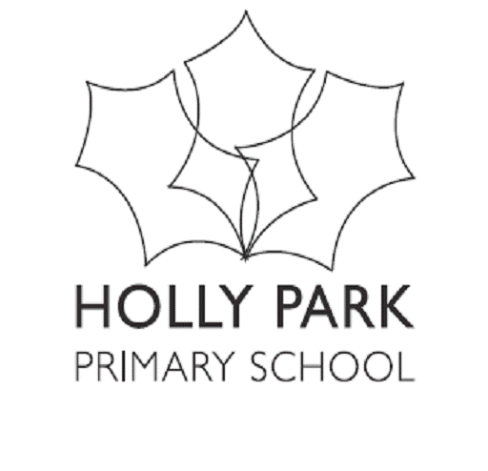
Bellevue Road, Friern Barnet, London N11 3HG
t: 020 8368 1434 f: 020 8361 6329 e: office@hollypark.barnetmail.net

Dear parent/carer

Notification of unacceptable behaviour

Name of child: ____________________________________________ Date: _________

In line with our Behaviour Policy, I am writing to inform you that your child was involved in an incident of unacceptable behaviour at school today, which involved the following behaviours and/or incidents:

The purpose of this letter is to alert you to the fact your child was spoken to by a senior member of staff, and was sanctioned according to our Behaviour Policy. We can assure you that the incident was fully investigated, and the school is satisfied that all those involved were dealt with fairly and appropriately, and as such, the matter is now closed.

We hope that this incident will not be repeated. If it is, or your child chooses to act in other unacceptable ways, you will be informed of this in a further letter. You will then be asked to contact the school to discuss your child’s behaviour with his or her teacher.

All we ask you to do now is return the slip below, so that we know you have read the letter, and talked to your child about the incident, and discuss steps which could have been taken, or decisions which could have been made, which would have prevented this outcome.

Thank you for your continued support.

Yours faithfully,

Re: Notification of unacceptable behaviour

Name of child: ____________________________________________ Date: _________

I have read the letter regarding an incident of unacceptable behaviour, and have spoken to my child about what happened.

Signed: _______________________________________________________________

Relationship to child: _____________________________________________________

HOLLY PARK PRIMARY SCHOOL

BEHAVIOUR ALERT FORM
NAME OF CHILD:

YEAR: | CLASS: |  |  | DATE OF ALERT:
TIME OF ALERT: ___________ (Circle or Highlight) Before School AM Break PM Break
Lunch In Class Assembly After School
LOCATION: (Circle or Highlight) Classroom Cloakroom Hall Shared Area Toilet
Playground Dining Hall Family Area
ALERTED BY:

ANTECEDANTS (what led up to this?)

BEHAVIOUR (Highlight or tick)
Hurting other children |  | Constant low level Disruption
Hurting adults |  | Fighting
Attempting to hurt adults |  | Using bad language
Saying hurtful things/teasing |  | Rudeness
Taking things that belong to others |  | Incitement (winding up)
Threatening others |  | Online Nastiness
Defiance |  | Misuse of ICT
Destroying things/graffiti |  | Racism
DESCRIPTION OF INCIDENT: (What did the child do?)
CONSEQUENCES / ACTION TAKEN:  (circle or highlight) |  |  | Date |  | Confirmed & signed
Time Out in Class/Thinking Time
Time Out in Another Class
Sent To a Key Leader
Playtimes Missed
Lunchtimes Missed
Sent to member of SMT
Parents Contacted
Sent to DHT or HT
Banned from Ball Area
Internal Exclusion
Fixed term Exclusion
OTHER (specify)
ANY SUPPORT NEEDED

